Missouri City Power Plant
Plant Overview

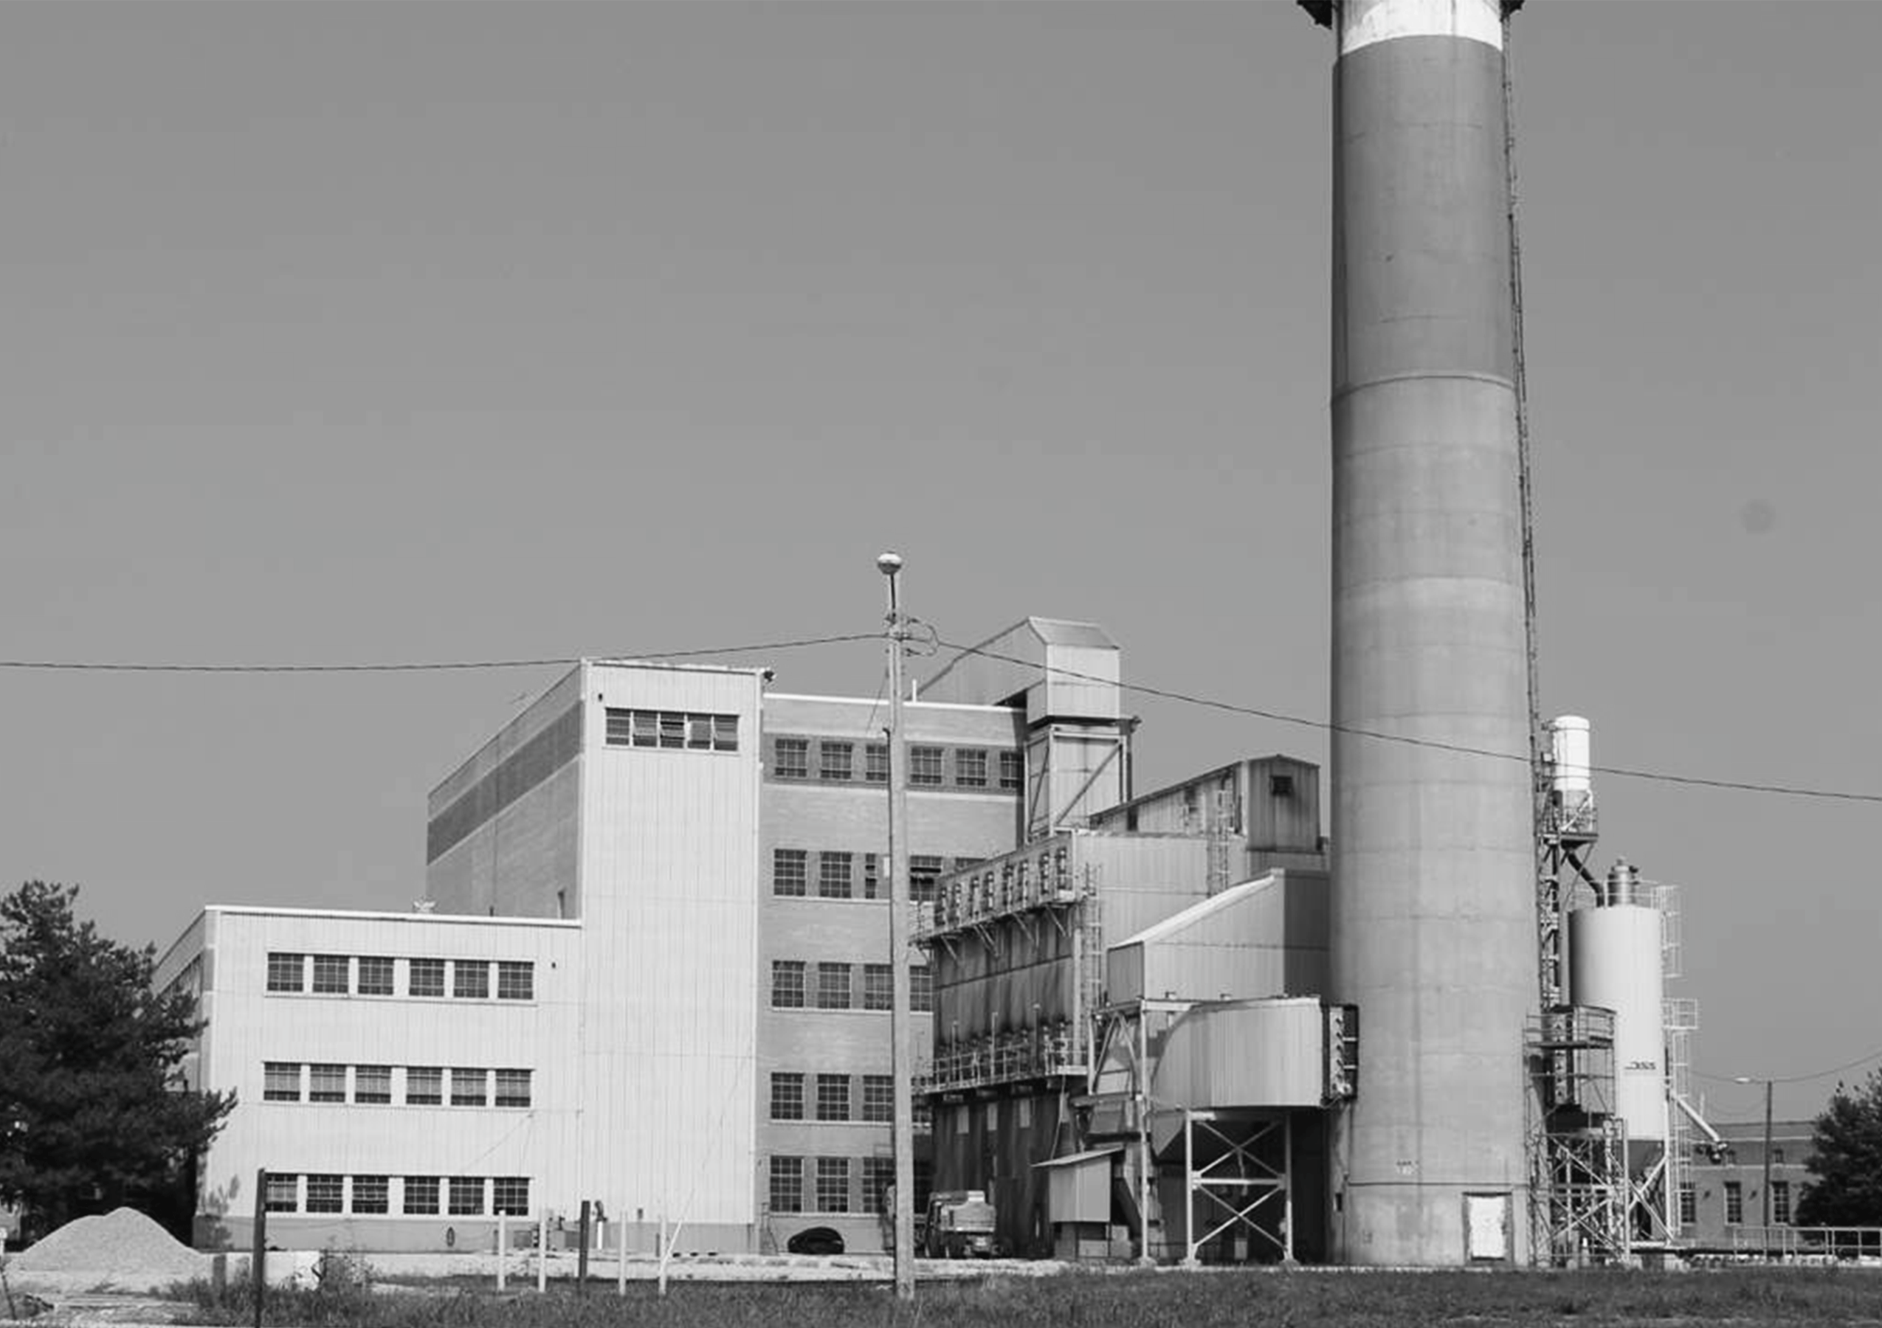

January 17, 2017

INTRODUCTION
The City of Independence, Missouri (“City”) is issuing a Request for Proposals (“RFP”) from entities are interested in and capable of providing divestiture services include ownership transfer for the Missouri City Power Plant (“Plant”), near the town of Missouri City, Missouri. The 87-acre Plant site is located approximately 18 miles east of downtown Kansas City, Missouri on the north bank of the Missouri River in rural Clay County, Missouri.
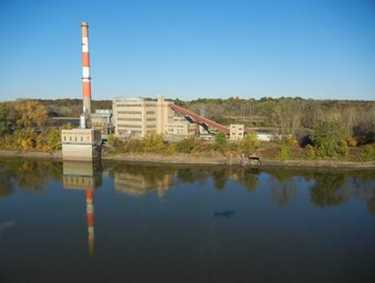
general description
The Plant consists of a steam-electric generating station, a switchyard, an ash pond, a river water intake, and a coal yard. The microwave tower, substation, and switch yard, which are owned by N. W. Electric Cooperative, Inc. (NWEC), remain in operation and will not be included in the RFP. The remainder of the site has ceased operation. The approximate 20-acre ash pond has been lined, capped, and covered to comply with the latest federal Coal Combustion Residue regulations. On top of a hill to the east on an adjacent 10-acre tract owned by the City, is a microwave communications tower that connects to the substation and switchyard, and a water storage tank that provides water to the plant site for fire protection from on-site water wells. Potable water is supplied to the Plant by the Clay County Utility Authority.
The Plant is accessible from Missouri Highway 210, and is located approximately six miles east of Missouri Highway 291. It is an early 1950’s vintage, twin unit coal-fired steam electric generating station that was built for NWEC. The City purchased the Plant in 1979 after an extensive fire. The Plant was returned to operation in the summer of 1982 after repairs and upgrades to comply with air permit regulations. The City’s Power & Light Department (IPL) operated the plant until September 2015. During the first five years the plant ran in continuous base-load operation, except for typical outages. From 1987 through 1997 the Plant was kept in standby mode, because IPL was able to contract for more economical power supplies. During the summer of 1998, the plant was returned to operation as required for IPL to meet its summer seasonal peak loads. In June of 2015, the City Council passed Resolution 5933 that mandated the end of energy production at the plant by the end of 2015. The Plant ceased generating electricity in September 2015.
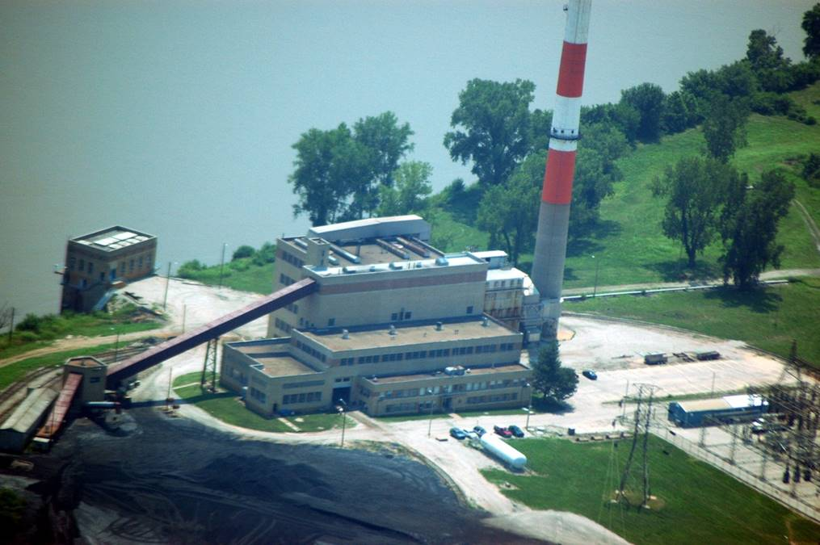
NON-POWER DEVELOPMENT OPPORTUNITY
The Plant site is situated to accommodate many alternatives for industrial, commercial or recreational uses. Motor vehicle access is afforded from Missouri Highway 210 on the northern site boundary. The BNSF Railroad owns and operates a
rail line along the northern edge of the site. There is an abandoned rail spur bed into the Plant that could be rebuilt to serve the site. The southern site boundary is the bank of the Missouri River which could be developed to facilitate barges. Thus the site provides opportunity for intermodal transportation transfers (highway/railroad/river) in a rural setting. Depending upon the intended final use, the power house structure could be converted to support dry or liquid storage of materials for intermodal transfer. The same attributes would also support industrial or commercial manufacturing operations.
Missouri Gas Energy (MGE) operates a natural gas pipeline approximately six miles west/southwest of the Plant at River Bend, Missouri. Known as the Liberty Lateral Pipeline, MGE operates the 12-inch diameter line at approximately 100 psig. Gas volumes and availability have not been confirmed. The closest high-pressure, interstate natural gas transmission line, operated by Rocky Mountain Express (REX), is approximately 30 miles to the north of the Plant site.
Potable water is currently supplied by the Clay County Utility Authority from the northeast. Four on-site wells feed a 500,000 gallon, semi-submerged, earthen covered, concrete tank at the top of a hill on an adjacent 10-acre tract owned by the City, which is included in the overall Plant site package. Currently the site utilizes an on-site lateral field for sanitary waste.
The microwave tower, electrical substation, and switchyard on the site are owned by NWEC. Transmission lines connect the substation with Kansas City Power & Light Company (KCPL) and IPL.
These utilities could be updated to support any number of industrial, commercial, or mixed-use development of the property.
The Site is currently classified as “Agricultural” for zoning purposes by the Clay County Planning and Zoning Department. No conditional or special use
permits have been required for the current ownership and operation. When it is sold and/or redeveloped, appropriate zoning approvals will need to be obtained from Clay County.
POWER PLANT DESCRIPTION
The Missouri City Power Plant consists of two identical generating units that were rated at 19 MW net per unit. The Plant started commercial operation in 1954 for NWEC. A fire destroyed many critical electrical components at the power station in 1975. The City purchased the Plant in 1979, refurbished, and returned it to commercial operation in 1981.
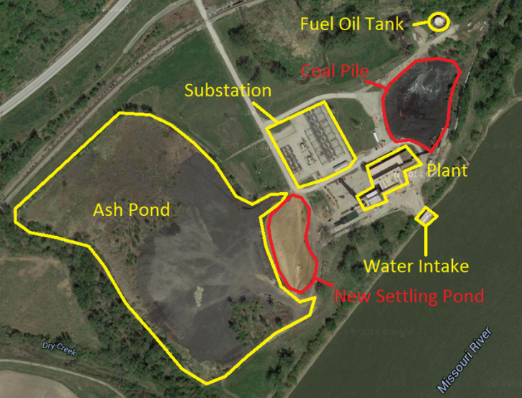
Each unit consisted of a pulverized coal-fired Foster Wheeler steam generator rated at 875 psig, 900 degrees F with a nameplate capacity of 220,000 pounds per hour. The boilers were each equipped with two Babcock & Wilcox Type E pulverizers and a bare tube tubular air heater. The boilers did not have economizers or reheaters. The steam turbine generators were Westinghouse 20,000-kW, single-cylinder, non-reheat cycle machines designed for throttle conditions of 850 psig and 900 degrees F, at an exhaust pressure of 1.5 inches Hg absolute. Each turbine cycle used four stages of feedwater heating. The steam turbine condenser was cooled with water supplied from the Missouri River and permitted for direct return to the river.
Each unit had a forced draft fan, induced draft fan, and air heater. Two electric-driven boiler feed pumps per unit provided feedwater to each boiler. In conjunction with the fire repairs, a common baghouse (reverse air type manufactured by Research-Cottrell), ductwork, induced draft booster fans, and a 300-foot reinforced concrete chimney were added.
The coal yard had an abandoned rail spur and a coal receiving hopper reclaim pit. Coal was stored in a common fuel yard. Coal was transferred from the fuel yard via a common conveyor system to individual bunkers (two per unit).
Both units had a fuel oil igniter system. The units were supplied with fuel oil from a common fuel oil unloading and storage facility. The 250,000 gallon fuel oil storage tank is located on the northeastern portion of the site.
The Plant was comprised of the following major systems and equipment that remain on the site:
- Two boilers and boiler auxiliaries.
- Two steam turbine generators, heat balance equipment, and auxiliaries.
- Common baghouse.
- Common chimney.
- Circulating water intake structure, with screens and pumps.
- Coal storage and handling conveyors.
- Abandoned concrete dock.
- Fuel oil handling and storage equipment.
- Administration building with common control room and maintenance shop.
- Coal crusher building.
- Fuel oil pump house.
- Miscellaneous small buildings and enclosures.
- Fire water systems.
- Four on-site water wells.
- 500,000 gallon untreated well water storage tank.
- Medium- and low-voltage electrical equipment.
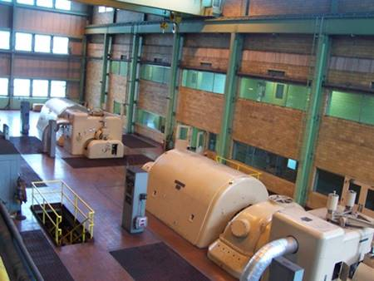
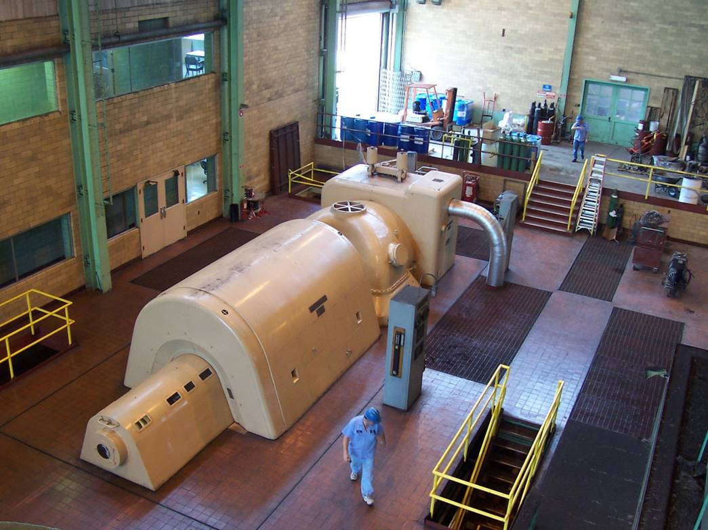
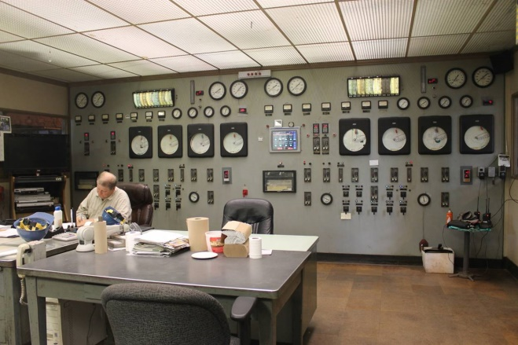

substation description
The two generators at the Plant previously fed into the NWEC Substation located immediately northwest of the Plant. These two 13.8-kV feeds were connected to two individual tertiary winding transformers that stepped the voltage up to 69-kV on the secondary winding and 161-kV on the primary side. The substation has three 69-kV lines that interconnect to the Kearney, Smithville, and Knoxville substations owned by NWEC. The substation also has four 161-kV interconnections;
one that connects to the Lathrop Substation owned by NWEC; two that connect to the Liberty South and Maurer Lake Substations owned by KCPL; and one that connects to the Eckles Road Substation owned by IPL and operated by NWEC. Thus transmission corridors transect the site. The NWEC microwave tower, substation and lines are not subject to this RFP. Any arrangements for future connection to the substation facility located on the Missouri City Plant property would require arrangements with NWEC.

Parcel Detail
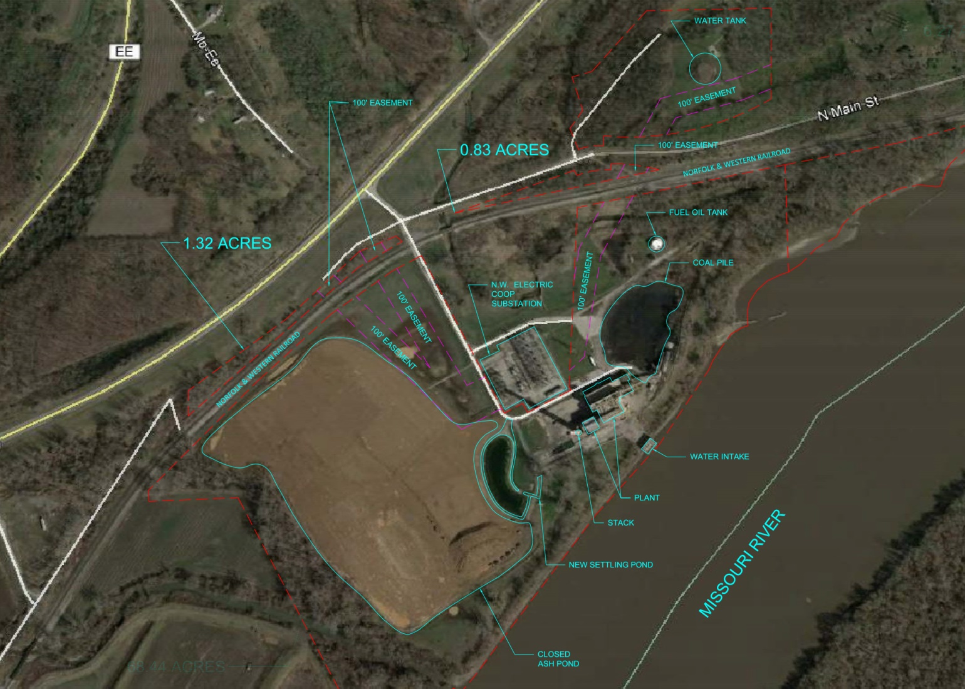

ENVIRONMENTAL SUMMARY

Existing Permits:
The facility holds two, Missouri Department of Natural Resources (MDNR)-implemented permits—Part 70 Air Operating Permit and a Water Permit. The Air Permit is current and expires April 6, 2020. The Water Permit expired February 5, 2014. IPL submitted the application to renew the Water Permit in August 2013 and is now in negotiations with MDNR to renew this in March 2017. IPL recently received a “No Exposure” Certification from MDNR signifying that the site did not have any stormwater discharges . IPL anticipates that the pending Water Permit will focus exclusively on groundwater protection.

Ash Pond Closure:
IPL operated a 23-acre Coal Combustion Residuals (CCR) impoundment (Ash Pond) onsite until September 2011 when ash sluicing to the pond ceased. This pond was capped and closed under the EPA CCR Rule September 27, 2016 (see Closure Certificate in Environmental Docs folder). In addition, this Ash Pond was the subject of a June 2011 Settlement Agreement between MDNR and IPL that directed IPL to conduct various studies and corrective actions. This Settlement Agreement was formally closed by MDNR on September 12, 2016, IPL having met all requirements of the 2011 Agreement (see SA Closure in the Environmental Docs folder). IPL installed twelve groundwater monitoring wells around the Ash Pond as a part of the Settlement Agreement. These wells were not closed with the closure of the Agreement. IPL anticipates that MDNR will require future groundwater monitoring utilizing these wells in the pending Water Permit.

Remaining Environmental Issues:
An extensive Asbestos Inspection was conducted at the power plant in January 2017. The inspection documented several thousand linear feet of asbestos-containing pipe insulation, several thousand square feet of asbestos-containing tile, as well as a variety of other asbestos-containing materials present in the main power and ancillary buildings. The inspection noted that all friable asbestos containing materials were in good condition. Detailed information on the location, condition, and asbestos content of remaining asbestos materials is located in the Asbestos Inspection Report in the Environmental Docs folder. When it still operated, the Missouri City Plant staged the coal in an approximately 3-acre coal pile just east of the power plant. Prior to ceasing generation on September 19, 2015, the plant burned all remaining, usable coal staged in the pile. The old 3-acre coal pile staging area however, does contain residual coal fines that remain in-place.

